# Project Development –Delivery plan sprint-2

IoT Based Safety Gadget for Child Safety Monitoring & Notification

**TEAM ID:**PNT2022TMID16946

**Creating and Connecting IBM cloud for Project and Python Code**

## Creating IBM Cloud Service and creating the device:

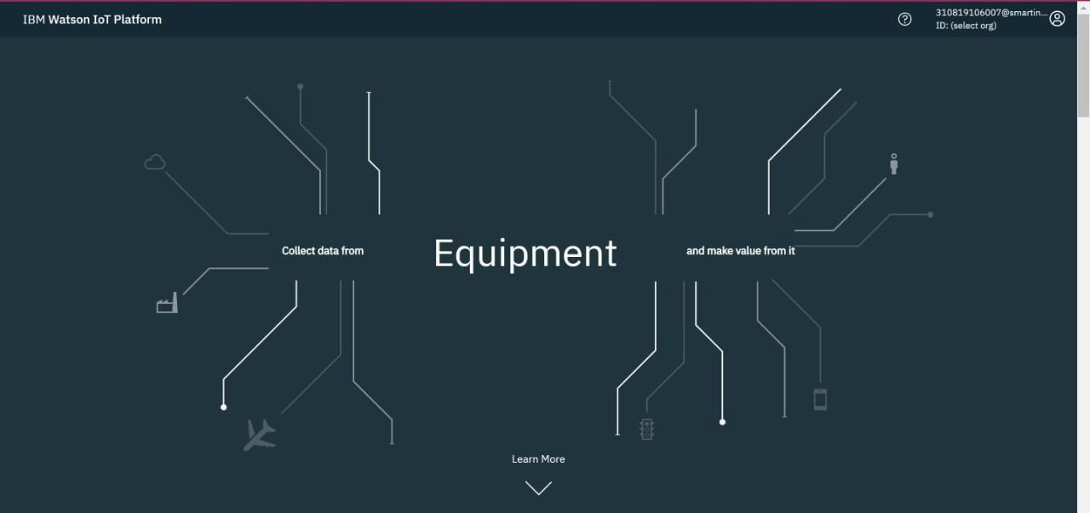

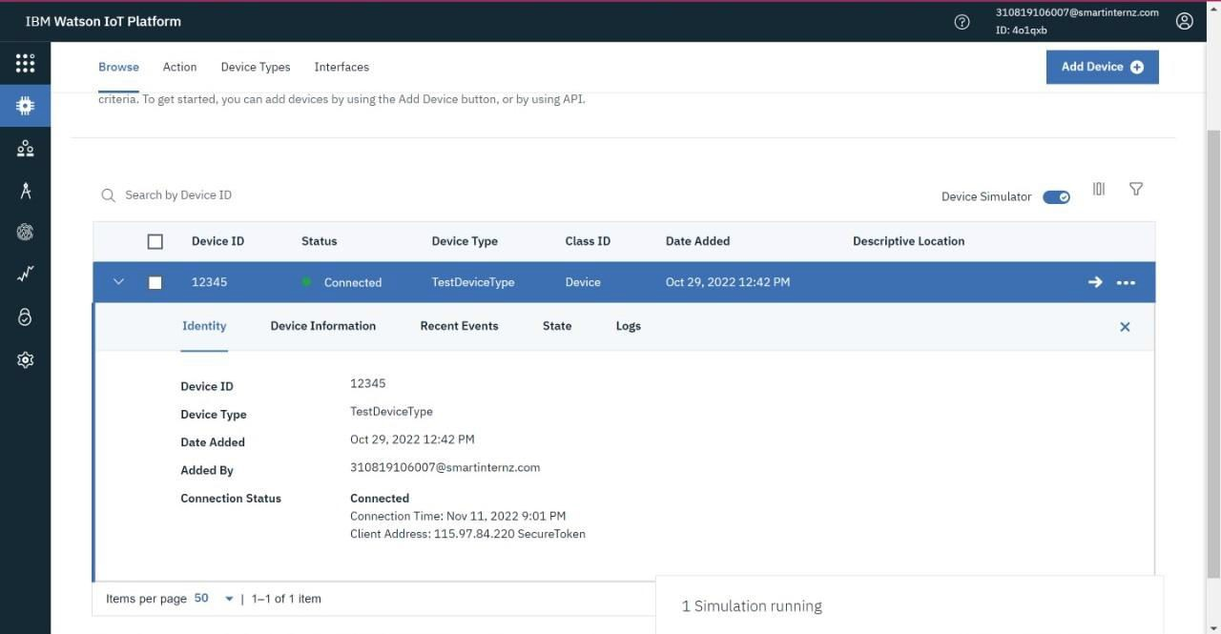

import json

import wiotp.sdk.device import time

import random myConfig = {

"identity":{

"orgId": "4o1qxb",

"typeId": "TestDeviceType", "deviceId": "12345"

},

"auth": {

"token":"pnhXvzN-sWMKv&hxyi"

}

}

client = wiotp.sdk.device.DeviceClient(config=myConfig, logHandlers=None) client.connect()

while True:

name= "Smartbridge"

#in area location

latitude= 17.4225176

longitude= 78.5458842

#out area location

#latitude= 17.4219272

#longitude= 78.5488783

myData={'name': name,'lat':latitude, 'lon' :longitude} client.publishEvent(eventId="status", msgFormat="json", data=myData,

qos=0, onPublish=None)

print("Data Published to IBM IoT platfrom: ", myData) time.sleep(5)

client.disconnect()

## In-Area Location:

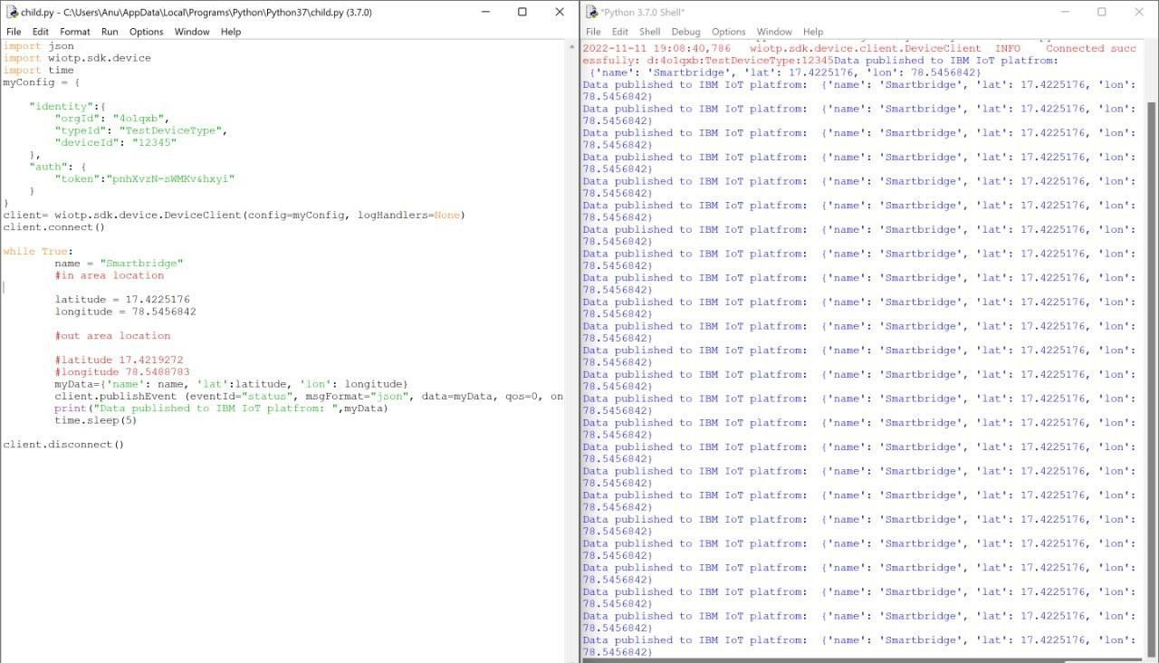

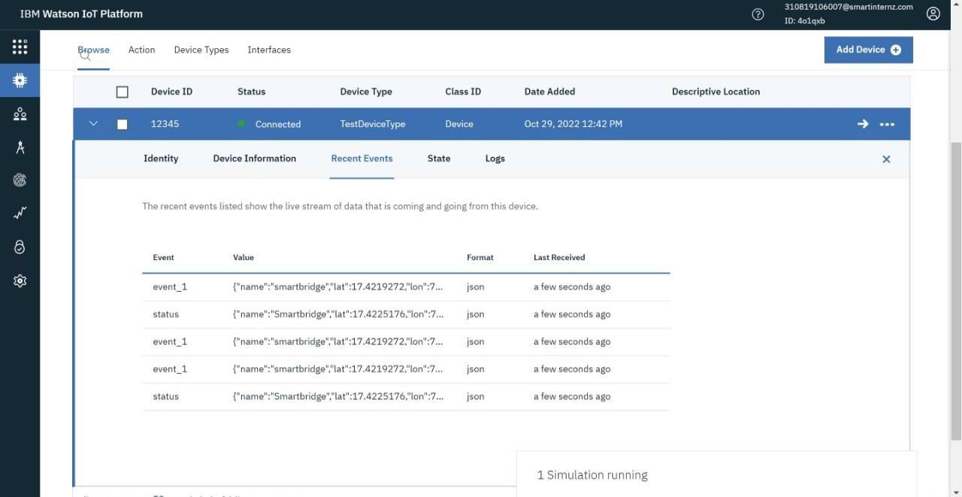

**Out-Area Location:**

